Subject: November: Financial Literacy Month
Hello,
November is Financial Literacy Month in Canada. To mark the occasion, our group retirement savings plan provider, iA Financial Group, is launching a communication campaign that will take place throughout the month.
If you’ve already subscribed to the group retirement savings newsletter from iA Financial Group, you will receive newsletters covering Financial Literacy Month this November. There, you can read about the experiences of three people from different backgrounds. Through their stories, you will learn more about the following topics:
- Paying debts
- Buying a first home
- The challenges of immigration
- Preparing for retirement
- And much more

Check out iA Financial Group’s newsletter to not miss a thing! If you haven’t already, subscribe now!
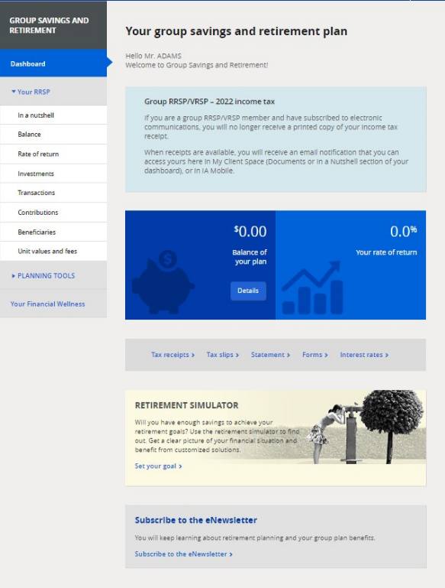
- Log in to My Client Space at ia.ca/myaccount and click on your group retirement savings plan dashboard
- If the newsletter banner appears at the bottom of the homepage, click “Subscribe to the eNewsletter”

Sincerely,
Sponsor’s signature

